Ques 1.
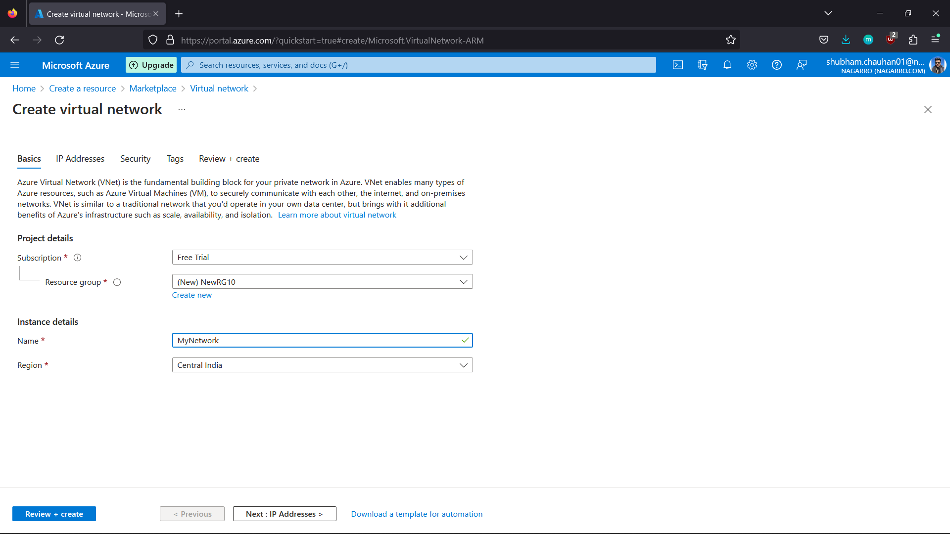

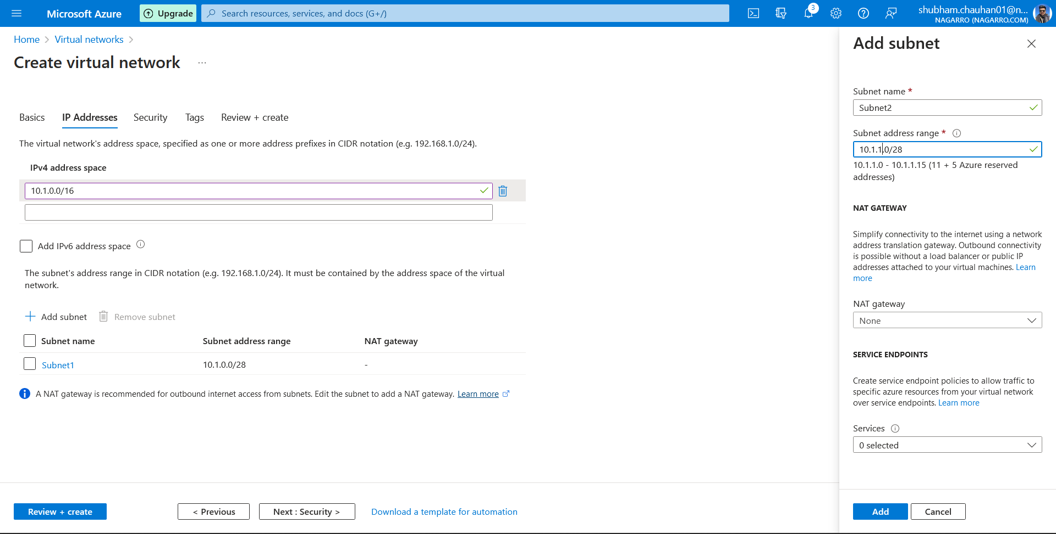
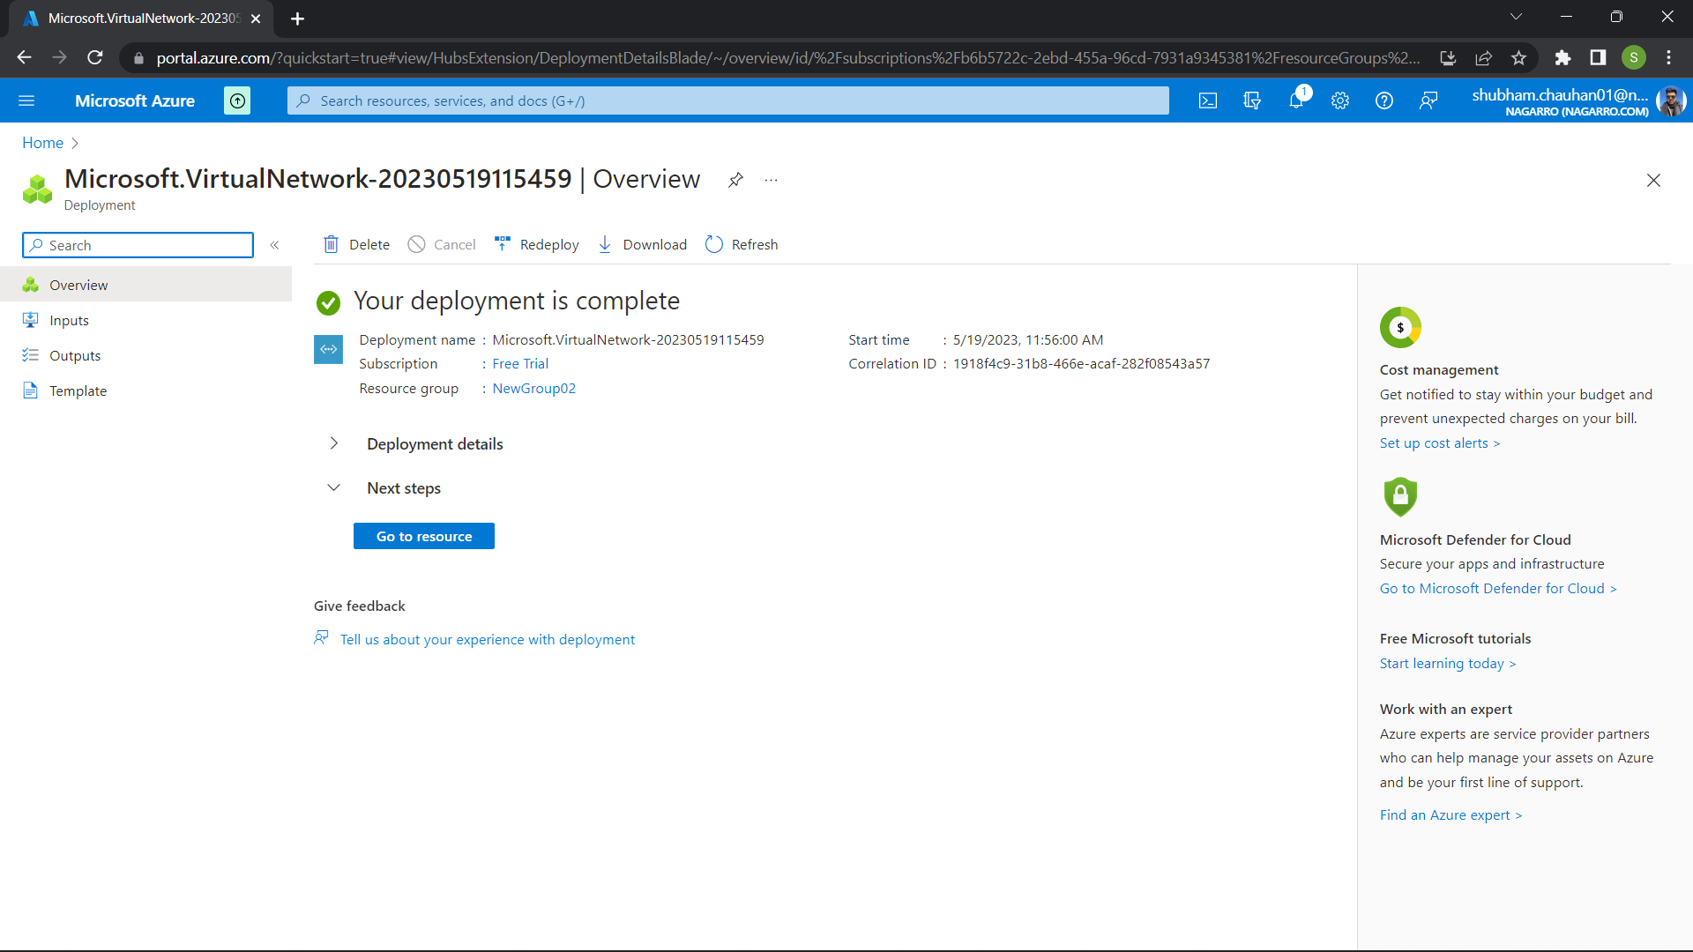

I have made the virtual network – MyNetwork with 2 subnets (subnet1 and subnet2) having 16ips only.

Ques 2. Inside one of the subnets, create a VM and deploy an application code inside it and it should leverage the database on the cloud (any existing application created by you before).

Ques 3.
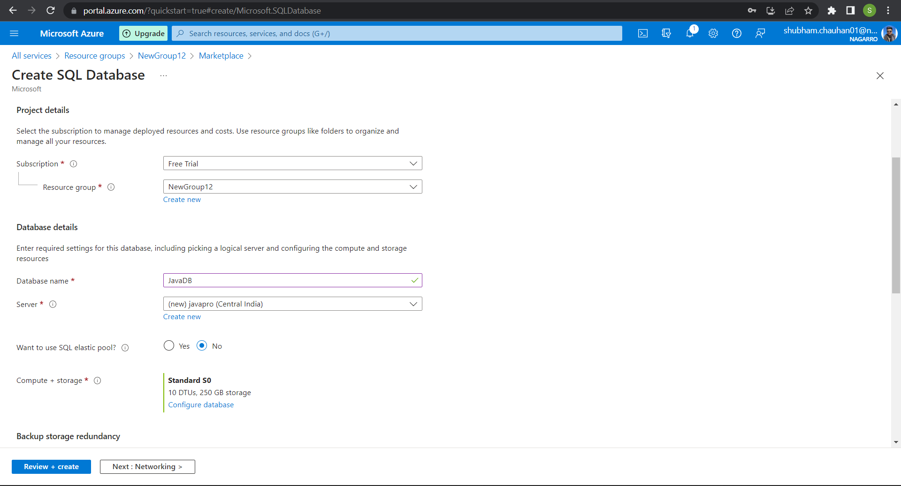
Creating Sql Database
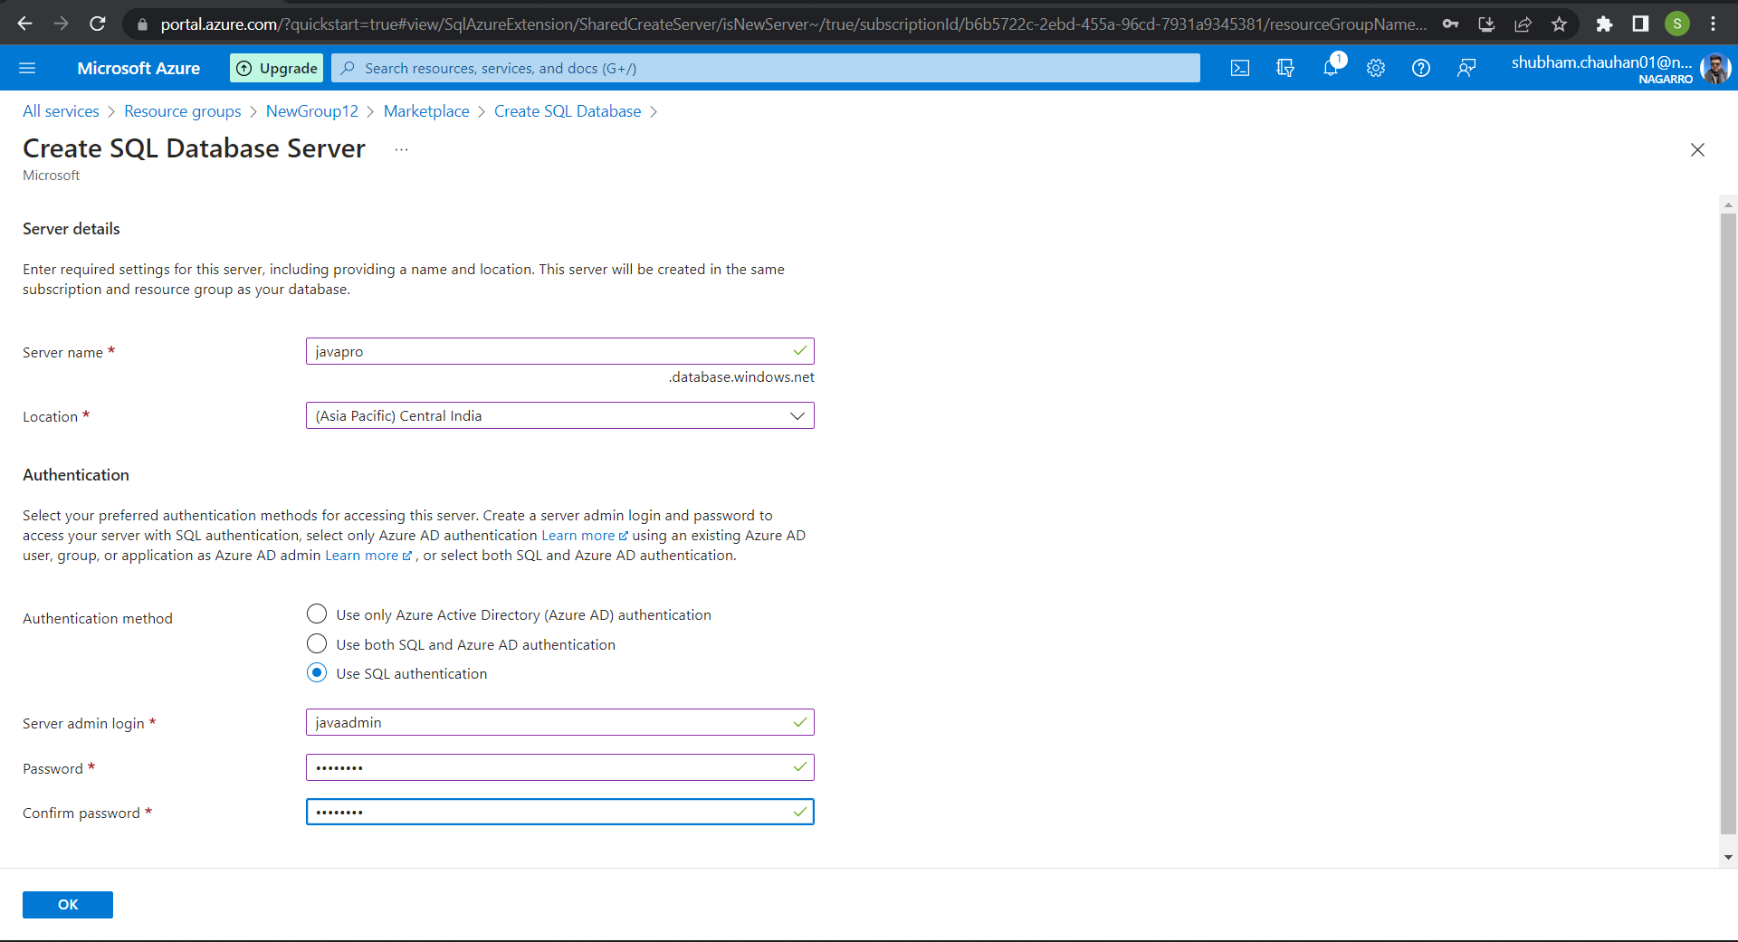
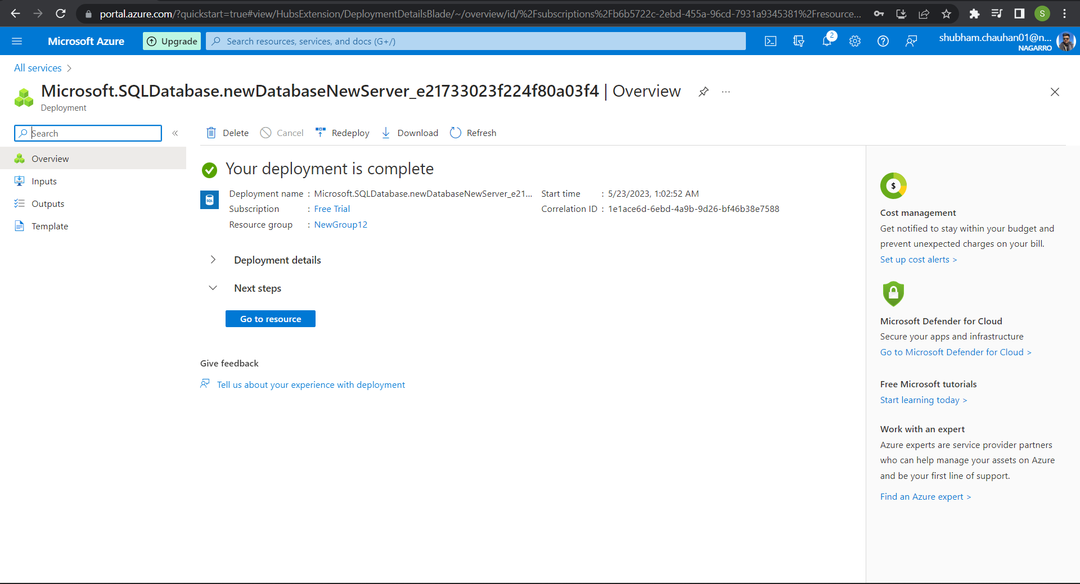

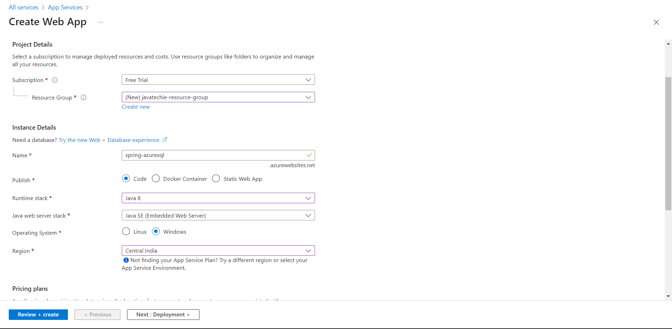
Deploying Web App
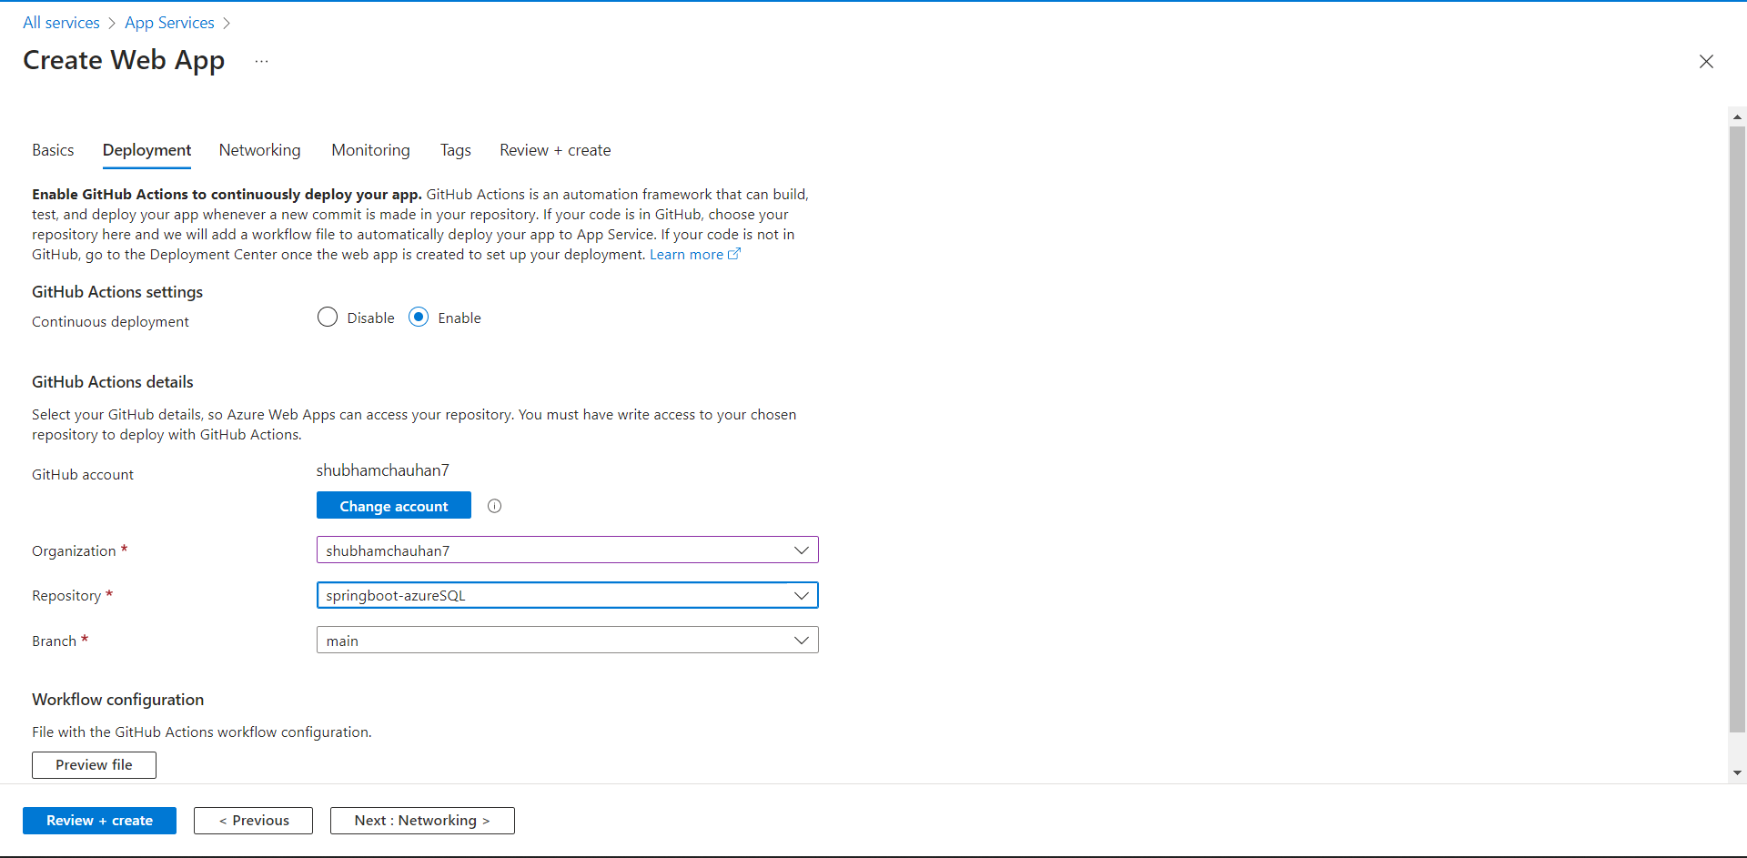

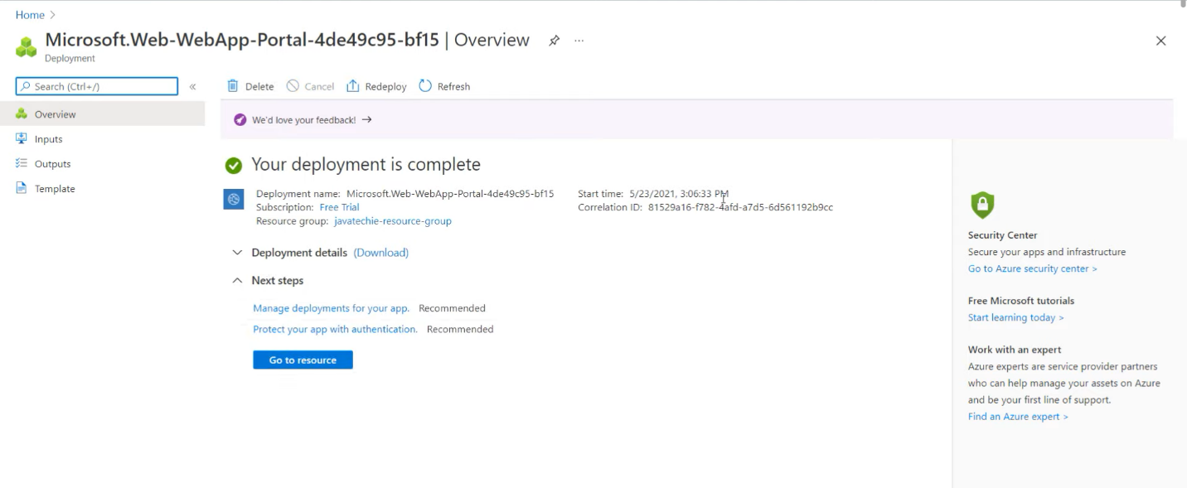

Ques 4. Create the AKS cluster (2 nodes, smallest size VM) and deploy any two services on it. Services should be accessible from the internet.

Ques 5.
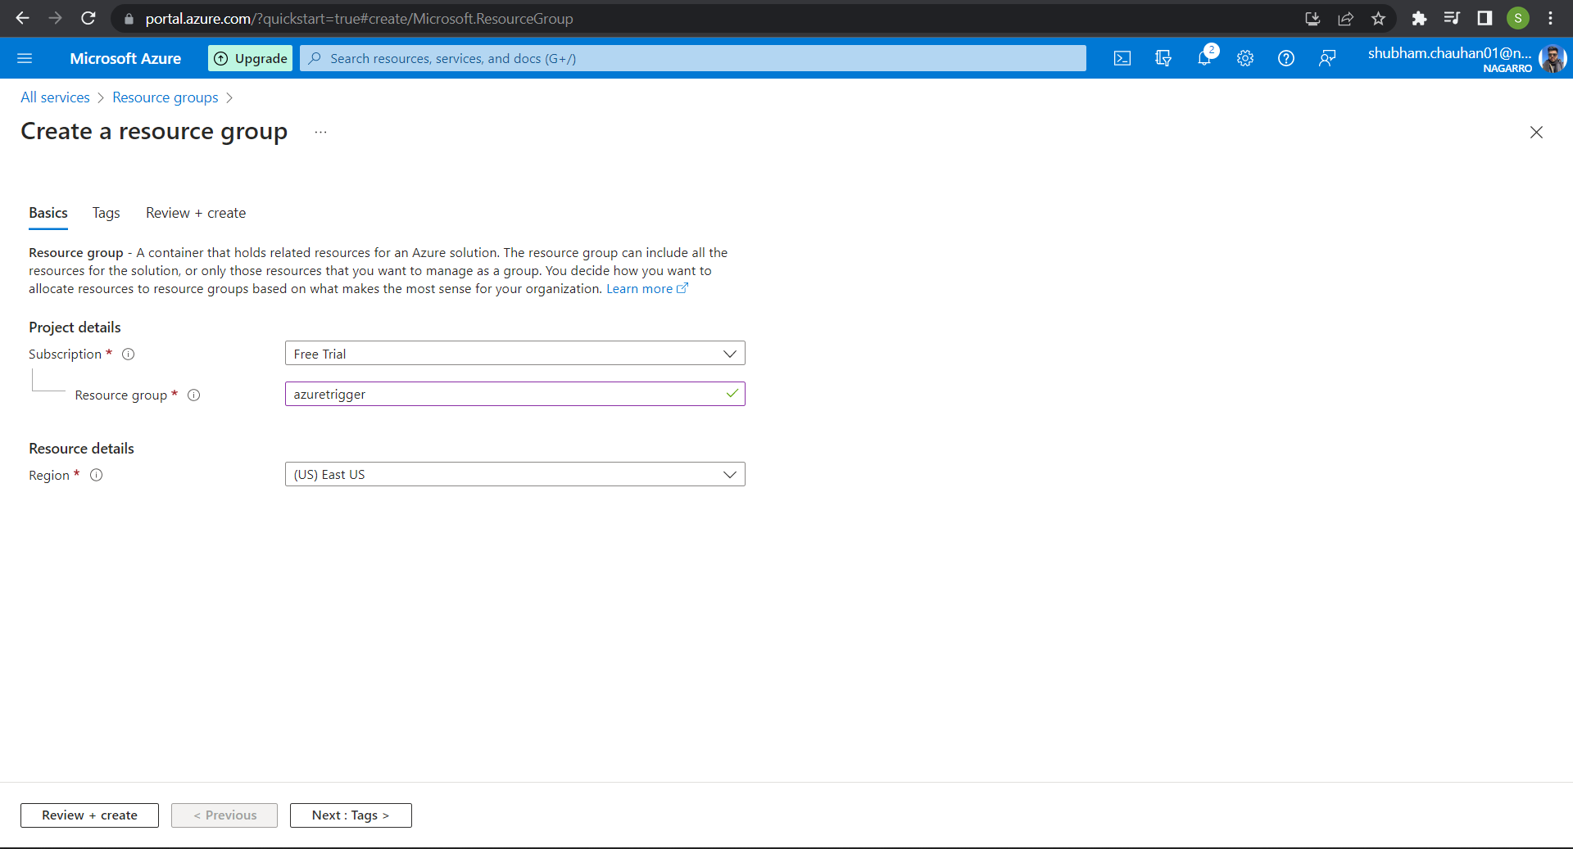
Created a new resource.

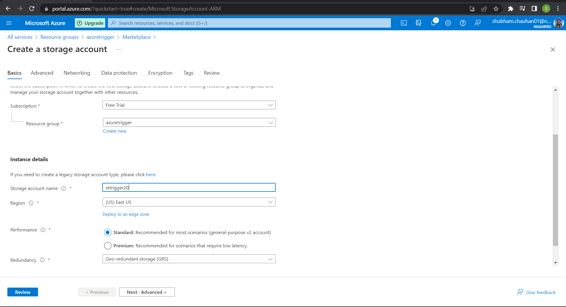
Created a new storage account.
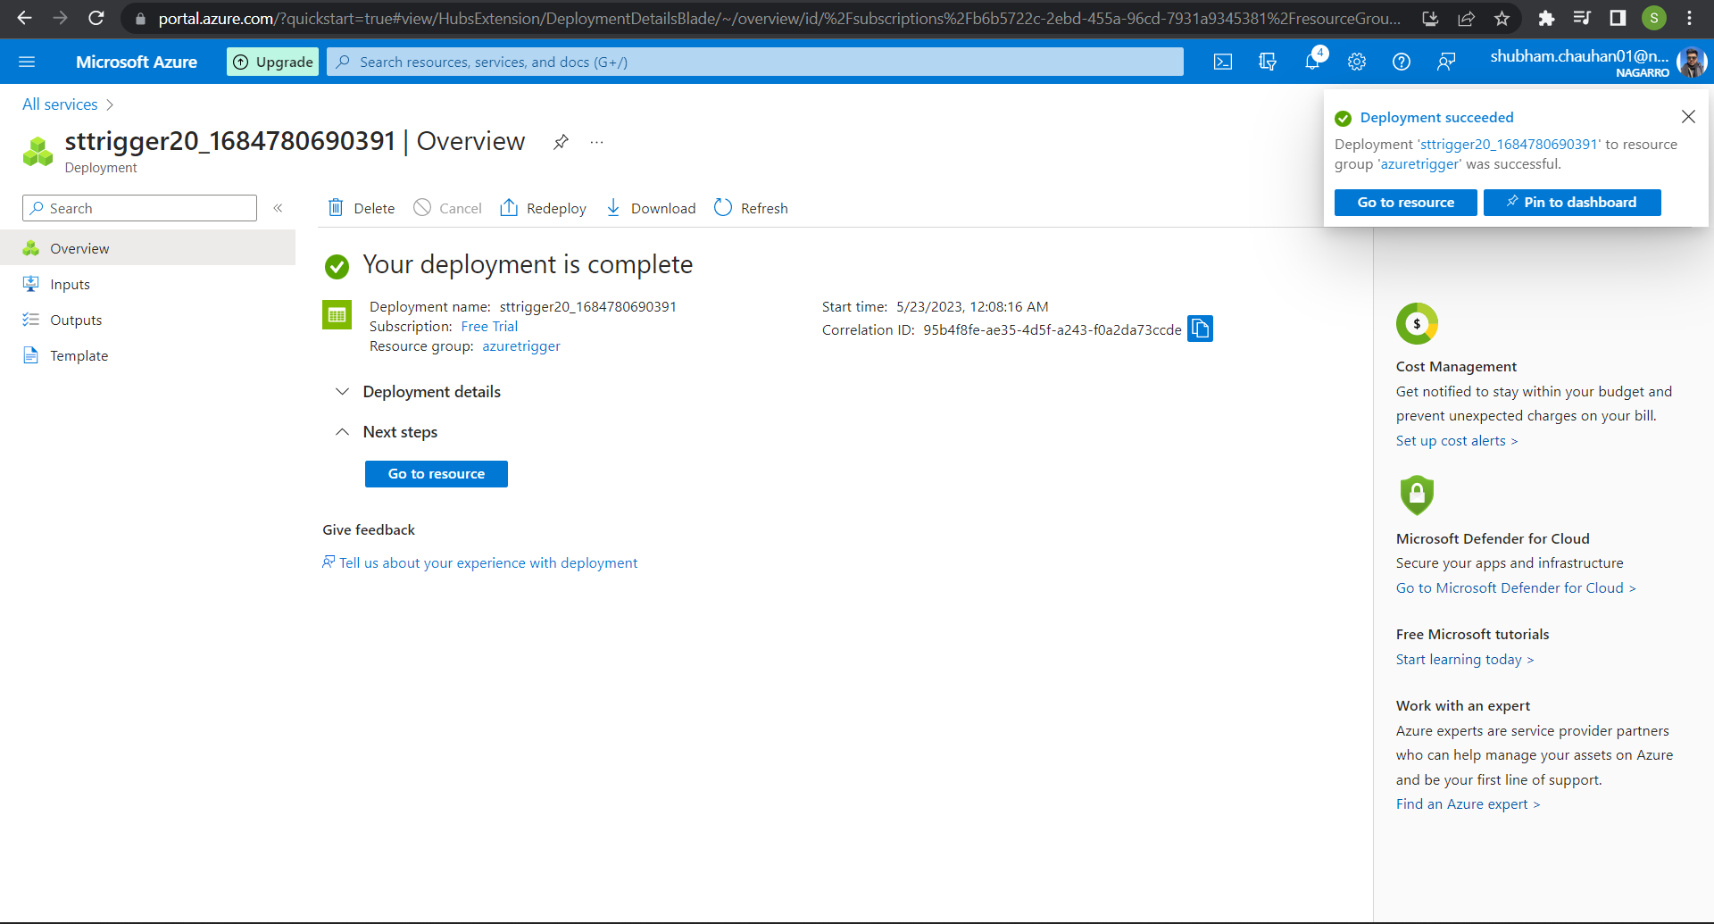

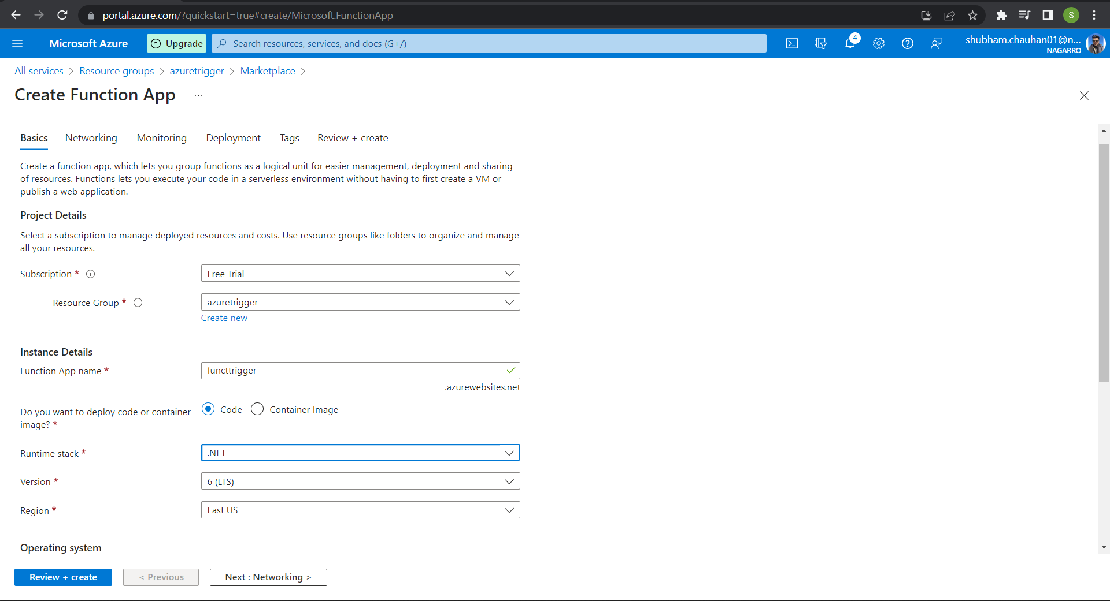
Created a new function app.
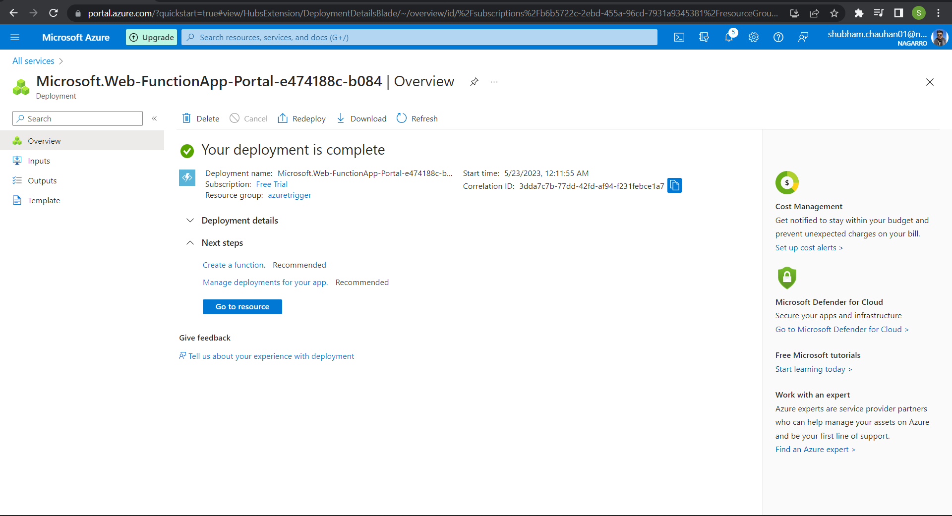

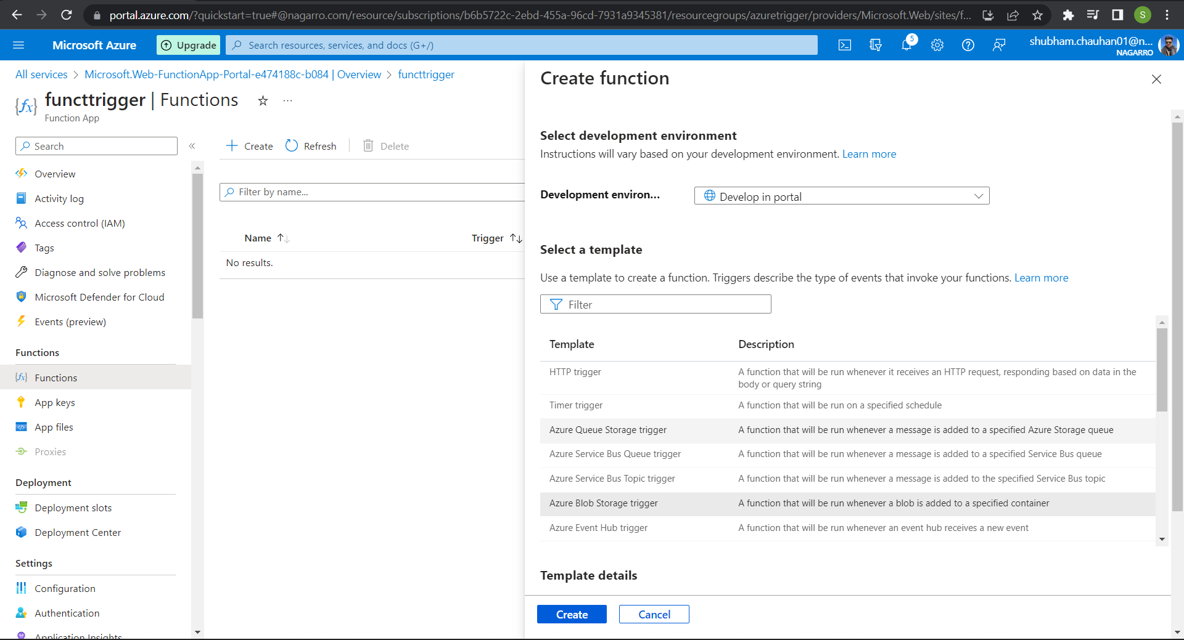
Selected the blob storage trigger
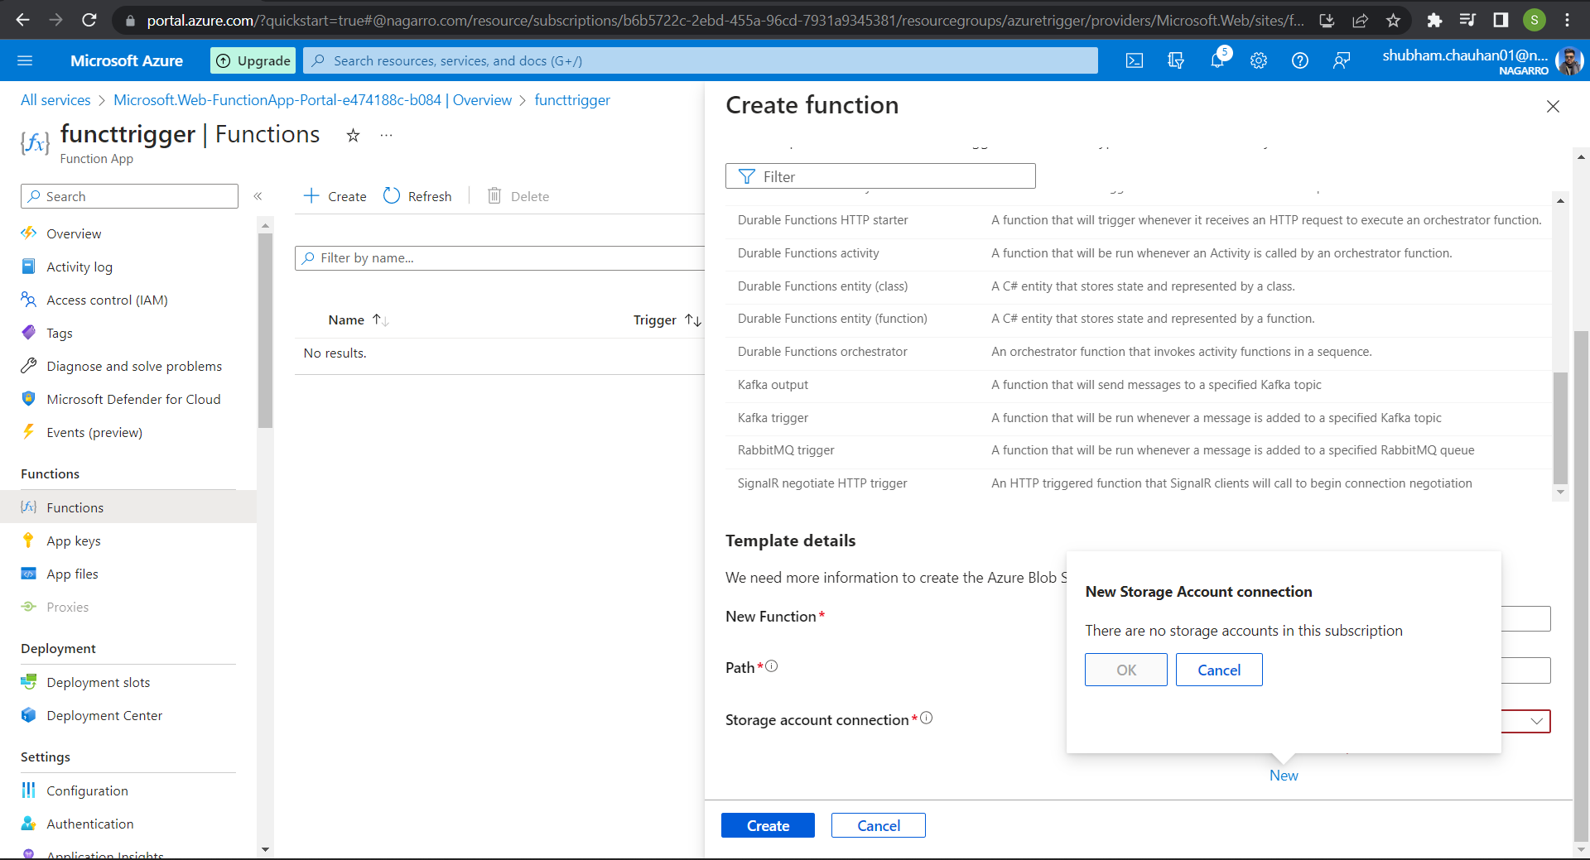
But then it showed this message even after creating the storage account.

